EXP.NO: 4
Create a web form that accepts a citizen’s details and service request. Write a Servlet to process the form data and display it back on the browser.
DATE: 06/02/2025
Aim:
To write a Java Servlet program that processes user input from a Smart City Service Portal and displays the submitted details such as name, selected service, and issue in the
ALGORITHM:
1. Input:
The user fills out a Smart City web form with their name, selects a service (like water, electricity, etc.), and enters an issue description, then submits it.
2. Form Handling and Servlet Processing:
1. Create the Web Form:
• Create an HTML form with input fields:
• Name of the citizen
• Service selection (Water, Electricity, Waste, etc.)
• Issue description
• Add a submit button to the form.
• Set the form’s action attribute to the Servlet URL and method to POST2.
Create the Servlet Class:
• Write a Servlet that processes the submitted form data.
• Override the doPost() method to handle form submission.
• Retrieve form data using:
3. Process the Data in the Servlet:
• Extract the values entered by the user.
• Validate the inputs (e.g., check if name is not empty).
• Prepare a response message confirming the request.
4. Send Response to the Browser:
- The Servlet sends a response like:
"Hello, [name]! Your request for [service] has been successfully submitted."
- The response is displayed in the browser.

5. Deploy the Servlet:
- Compile the Servlet.
- Deploy it on a servlet container like Apache Tomcat.
- Map the Servlet using annotations or web.xml.
6. Test the Application:
• Open the browser.
• Enter details in the form.
• Submit the form.
• The Servlet processes and displays the response.Code:
Index.html:
<!DOCTYPE html>
<html>
<head>
<meta charset="UTF-8">
<title>Smart City Portal</title>

<style>
body {
font-family: Arial;
background: linear-gradient(135deg, #0f2027, #203a43, #2c5364);
color: white;
display: flex;
justify-content: center;
align-items: center;
height: 100vh;
margin: 0;
}

form {
background: #1c2b36;
padding: 30px;
border-radius: 12px;
width: 400px;
box-shadow: 0 0 20px #00f7ff;
}

h1 {
text-align: center;
color: #00f7ff;
}

label {
margin-top: 10px;
display: block;
}

input, select, textarea {
width: 100%;
padding: 10px;
margin-top: 5px;
border-radius: 6px;
border: none;
}

input[type="submit"] {
background: #00f7ff;
color: black;
font-weight: bold;
margin-top: 15px;
cursor: pointer;
}

input[type="submit"]:hover {
background: #00ff88;
}
</style>
</head>

<body>

<form action="ClientServlet" method="post">

<h1>🌆 Smart City Portal</h1>

<label>Name:</label>
<input type="text" name="name" required>

<label>Select Service:</label>
<select name="service">
<option>Water Supply</option>
<option>Electricity</option>
<option>Waste Management</option>
<option>Road Maintenance</option>
</select>

<label>Describe Issue:</label>
<textarea name="issue" rows="3"></textarea>

<input type="submit" value="Submit Request">

</form>

</body>
</html>
ClientServlet.java:
package com.example;

import java.io.IOException;
import java.io.PrintWriter;
import javax.servlet.ServletException;
import javax.servlet.annotation.WebServlet;
import javax.servlet.http.HttpServlet;
import javax.servlet.http.HttpServletRequest;
import javax.servlet.http.HttpServletResponse;

@WebServlet("/ClientServlet")
public class ClientServlet extends HttpServlet {
private static final long serialVersionUID = 1L;

protected void doPost(HttpServletRequest request, HttpServletResponse response)
throws ServletException, IOException {

String name = request.getParameter("name");
String service = request.getParameter("service");
String issue = request.getParameter("issue");

response.setContentType("text/html");
PrintWriter out = response.getWriter();

out.println("<html>");
out.println("<head><title>Smart City Response</title>");

out.println("<style>");
out.println("body { font-family: Arial; background: #0f2027; color: white; display:flex; justify-content:center; align-items:center; height:100vh; }");
out.println(".box { background:#1c2b36; padding:30px; border-radius:10px; box-shadow:0 0 20px #00f7ff; text-align:center; width:400px; }");
out.println("h1 { color:#00f7ff; }");
out.println("a { display:inline-block; margin-top:15px; color:black; background:#00f7ff; padding:10px 20px; text-decoration:none; border-radius:6px; }");
out.println("</style>");

out.println("</head>");
out.println("<body>");

out.println("<div class='box'>");
out.println("<h1>✅ Request Submitted</h1>");
out.println("<p>Hello <b>" + name + "</b></p>");
out.println("<p>Your request for <b>" + service + "</b> has been received.</p>");
out.println("<p><b>Issue:</b> " + issue + "</p>");
out.println("<p>Our Smart City team will resolve it soon 🚀</p>");
out.println("<a href='index.html'>Go Back</a>");
out.println("</div>");

out.println("</body>");
out.println("</html>");
}
}

OUTPUT:

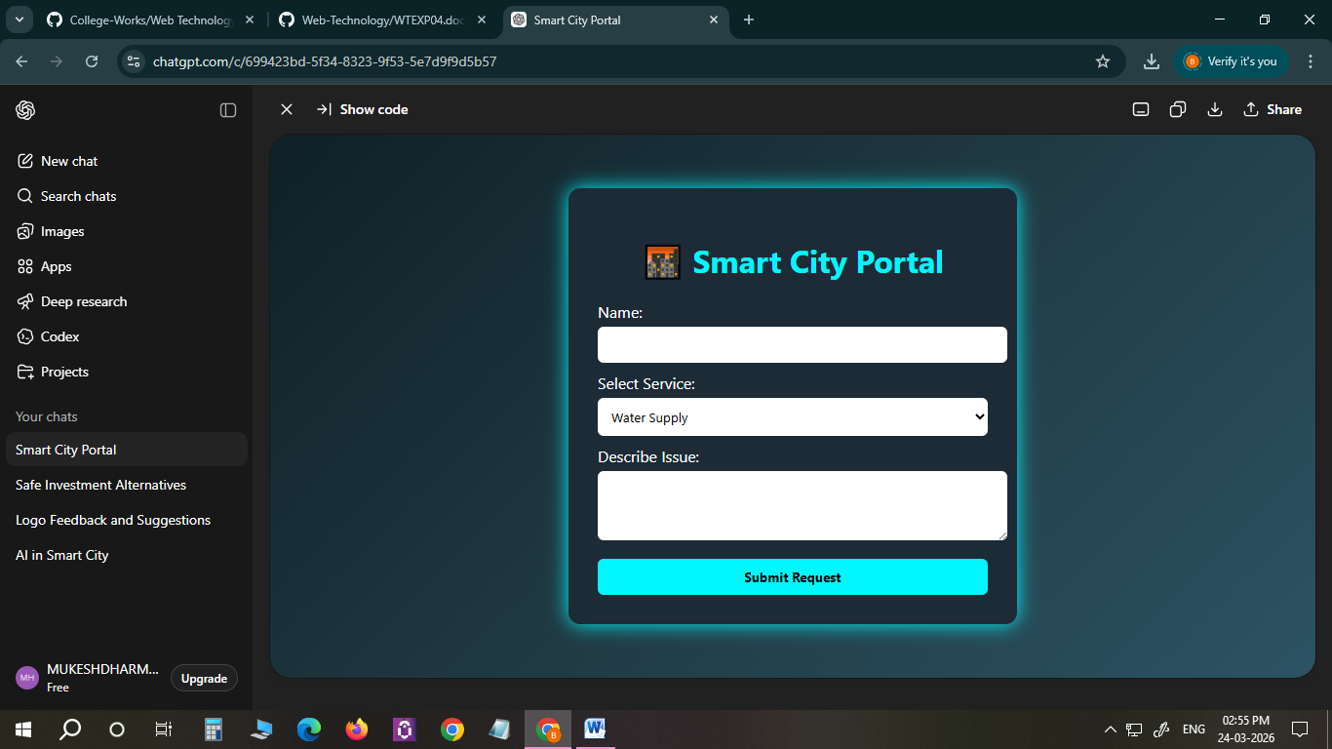

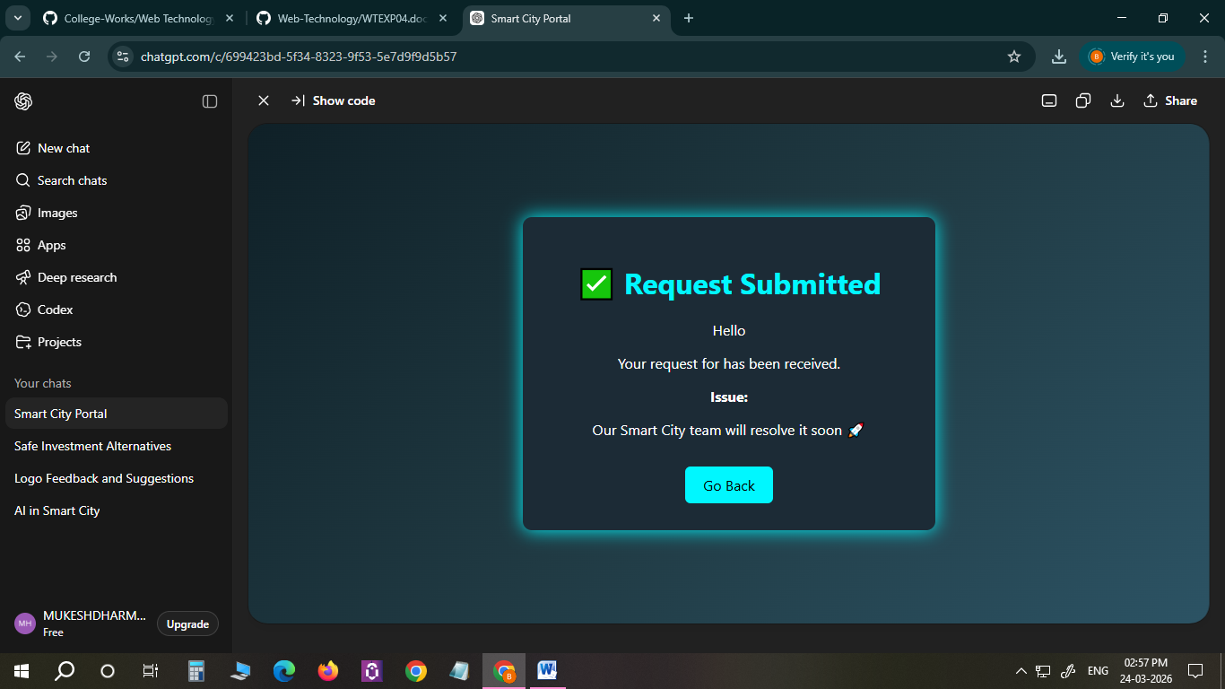

RESULT:
The Smart City Service Portal was successfully created using HTML and Java Servlet.
The user was able to enter their details and submit a service request.
The Servlet processed the input and displayed the submitted information on the browser successfully.

